**Case Study 1**

**Profile of M/s C Industries**

|  |  |
| --- | --- |
| **Name of Enterprise** | **M/S C Industries** |
| **Proprietor** | Shri RC |
| **Constitution** | Sole Proprietor |
| **Factory Address** | Sangareddy |
| **Established** | 2013 |
| **Line of activity** | Manufacturing of automobile sheet metal press components and Deep Draw Metal Components. |
| **SSI Registration No./Udyog Aadhaar** |  |
| **GST** |  |

**Line of Activity:**

Entrepreneur engaged in Manufacturing of automobile sheet metal press components and Deep Draw Metal Components. These components are used in automobile, cosmetic, explosive industries. The unit is also engaged in job works for general engineering and fabrications units.

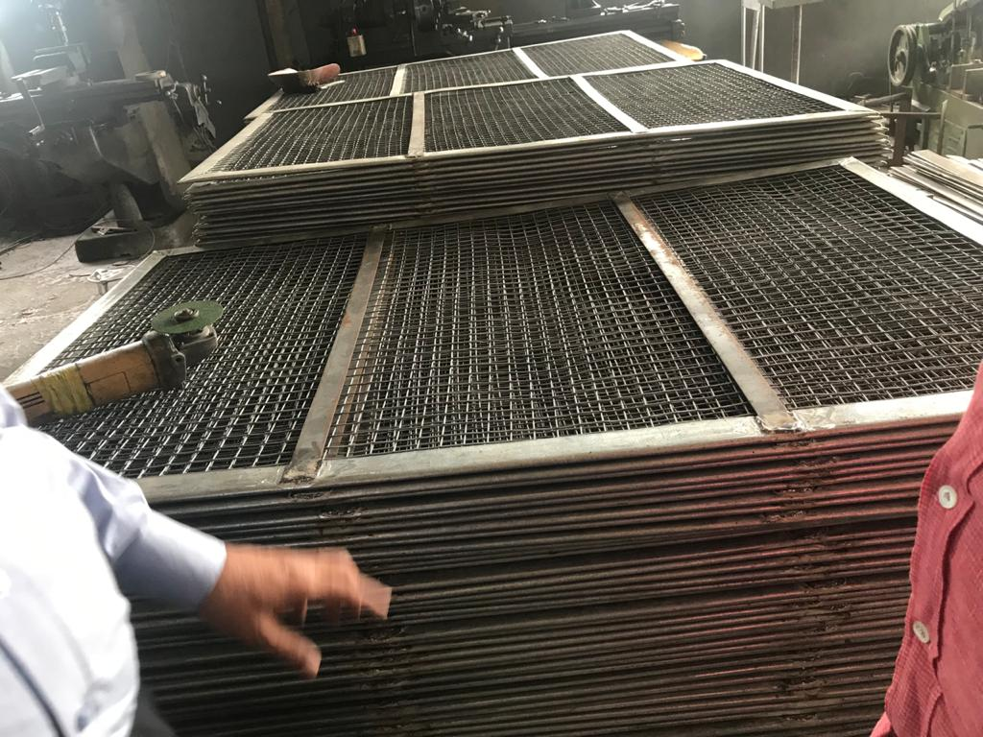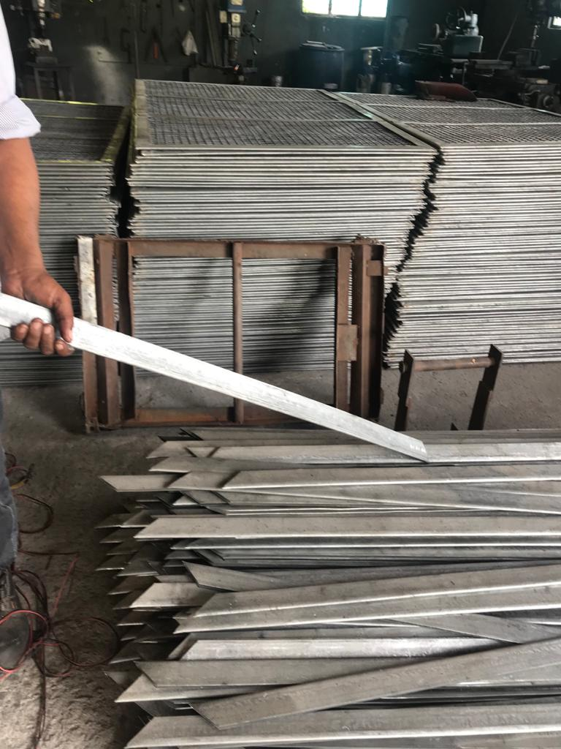

1. **Managerial Competencies**:

The proprietor Shri RC is well educated, did Masters’ in Mechanical Engineering and gained relevant work experience in U.S.A for 20 years.

1. **Manufacturing Process & Machinery:**

The unit is engaged in manufacturing of automobile sheet metal press components and Deep Draw Metal Components. The machinery used for the process are cutting and pressing machine. The raw material purchased is cut into specific shapes and then transferred to the molding & pressing machine. These components are used in automobile, cosmetic, explosive industries. The unit is also engaged in job works for general engineering and fabrications units. The firm buys the raw material in open market on cash and carry basis. The firm must buy the material by advance payment and process it and sell in the market on credit.

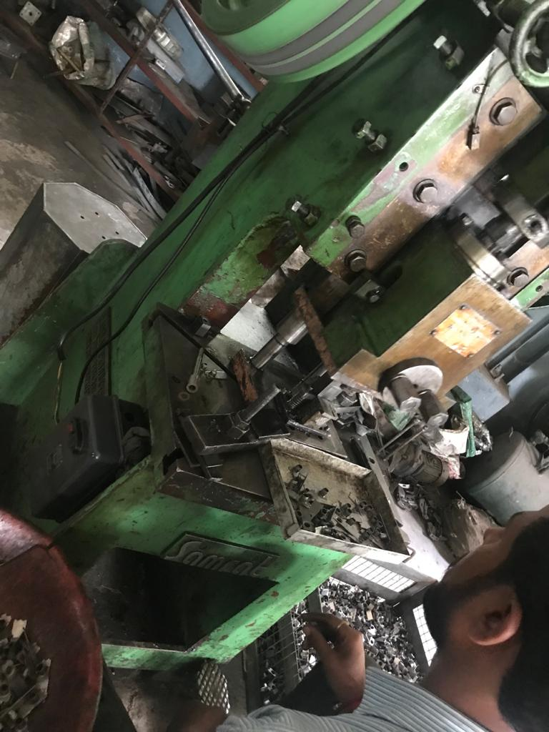 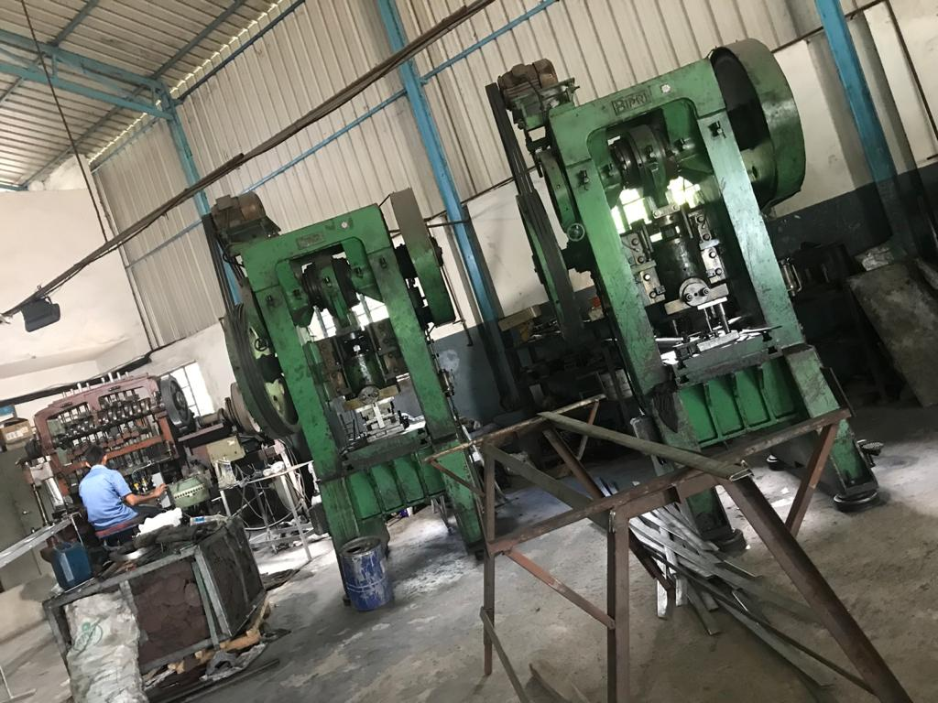  
**\* M/S C Industries**

1. **Marketing:**

* The company has good number of orders.
* Recently, the unit has received work order to manufacture Royal Enfield silencer spares, if this work order is funded the company will be out of stress

**TIHCL intervention:**

The client has initially approached TIHCL for priority release of sanctioned incentives for the revival of the unit. Meanwhile, they received work order to manufacture Royal Enfield silencer spares. Since they have exhausted all the ways to get required formal working capital from the market and also the release of incentives is likely to take some time, the entrepreneur has requested for other alternative funding to save the unit and employment.

TIHCL has diagnosed the enterprise and identified following reasons of sickness

* Lack of formal working capital limits
* To fund its operations the unit is relying on the raw materials supplied by the buyers of the products; this dependency for raw materials, has eroded the profit margins of the unit considerably. Low profit margins due to lack of negotiation in purchase of raw materials. As vendor, he is compelled to source RM at high cost eroding the profitability
* Giving long credit period
* No apt financial planning
* Investment Subsidy was sanctioned in 2016 the funds are yet to be released
* Non-receipt of Stamp Duty Reimbursement and Reimbursement of Land Cost
* Following factors were considered for the revival of the unit after in-detailed discussions with entrepreneur and taking into the consideration of the consultant’s Study Report.

As per TIHCL resolution package, TIHCL has Sanctioned Bridge Loan of Rs 0.78 million of sanctioned investment which can be used for unit’s working capital requirement.

|  |  |  |
| --- | --- | --- |
| **Key indicators** | **Pre-Revival** | **Post TIHCL intervention** |
| No of EMIs pending with primary lender | 0 | 0 |
| Capacity Utilization | 50% | 60% |
| Turnover | Rs 2.3 million | Rs 3.2 million |
| Employment | 12 | 14 |

1. **Labour Status: (post TIHCL intervention)**

|  |  |  |
| --- | --- | --- |
| Gender | Skilled | Unskilled |
| Men | 2 | 10 |
| Women | 0 | 2 |
| Total | 2 | 12 |

**Livelihood: At 60% capacity they have employed 14 workers and their families are dependent on this enterprise which is around 30 individuals including entrepreneurs. In full capacity there will be need of another 2-3 workers.**